**Course Description:**

This U.S History course traces the political, economic, and social development of the United States starting from the Civil War Period to Present Day (1860’s – 2000’s). Student activities will include research and analysis of historical events, thematic individuals, group projects, and contemporary issues. This course is designed to reflect the Florida U.S History End-Of-Course Exam and satisfies graduation requirements for the State of Florida. The U.S History End-Of-Course Exam WILL account for 30% of your overall final grade, in this class.

**Textbook:**

* U. S. History America Through the Lens, Student Edition - ISBN: 9781337111911

**Materials:**

* Binder with 10 - Dividers
* Pen (Blue/ Black) or pencil

**Required APPS & Codes:**

* ***Remind***
  + **Text #:** 81010 or Download Remind App
  + **Code:** @USLOPEZ
* ***Turnitin.com***
* ***Googe Classroom***
* ***Consent Form***: <https://forms.office.com/r/UjR2EP4Exi>
  + **Consent form MUST be digitally signed by parent (due 08/22)**

|  |  |  |
| --- | --- | --- |
| **COHEA Leadership Foundation** | | |
| **HONOR**   * + We will always   + Tell the truth   + Do the right thing   + Be team players   + Take responsibility for our actions   + Be hard working   + Be proactive, not reactive | **RESPECT**   * + We will always   + Respect the rights of others to learn   + Show respect for ourselves, our school, and others   + Conduct ourselves in a courteous and appropriate manner   + Be compassionate towards all members of Bulldog Nation   + Be considerate of others’ opinions | **LOYALTY**   * + We will always   + Care for others to build trust   + Help others reach their potential   + Steer clear of gossip   + Strive to be consistent and reliable   + Stay true to our words   + Be humble |

**Cellphones:**

At the beginning of class all students will be directed to place their phones in Cellphone Parking Lot, unless otherwise specified. Students who keep and use their phones without permission may have their device sent to the office to be picked up by parent at the end of the day.

**Consequences: [Hero will be used to enforce consequences]**

* + 1st Consequence – Verbal Warning
  + 2nd Consequence – Parent Contact
  + 3rd Consequence – Classroom Exclusion and/or Detention
  + 4th Consequence – Referred to the Administration

|  |  |  |
| --- | --- | --- |
| **Grading Policy** | **Categories** | **Assignment Percentage %** |
| * + A 100 –90 | * + Major Assessments/Test | * + 30% |
| * + B 89 –80 | * + Minor Assessments/Quizzes | * + 25% |
| * + C 79 –70 | * + Project/Presentations | * + 20% |
| * + D 69 –60 | * + Classwork | * + 20% |
| * + F 59 – below | * + Homework | * + 5% |
|  |  |  |
|  | * + Total | * + 100% |

Student with a D or Lower will receive a failure notice and communication with parents/guardian will be made.

**Make-up/Late Work:**

* I do not accept late work unless we have made prior arrangements. Make sure to communicate with me via email, remind or teams.
* **Excused Absences:** 
  + Missed assignment will be due at the beginning of class on the first day of the following week; meaning you have the weekend to complete any missed assignment(s)
  + If the missed assignment is not completed during the allotted time, no extra time will be given, and this will result in a failed grade for this assignment.
  + I WILL **NOT** REMIND YOU ABOUT MAKE-UP WORK.
  + IT IS YOUR RESPONSIBILITY TO ASK AND DO ANY MISSED ASSIGNMENTS.
  + IF YOU DO NOT UNDERSTAND THE ASSIGNMENT, IT IS YOUR RESPONSIBILITY TO ASK QUESTIONS AND MEET WITH ME FOR FURTHER CLARIFICATION.
* **Unexcused absences:**
  + Students will not be allowed to make up work with-out an excused absence.
    - Please see school-wide policy for what constitutes as an excused absence
  + Will result in failing grades for every assignment missed.
  + There are exceptions to this rule, depending on the circumstances.
  + **COMMUNICATION IS KEY!** You may contact me via Remind, email or Edmodo.

**NOTE: SYLLABUS IS SUBJECT TO CHANGE THROUGHOUT THE SCHOOL YEAR**

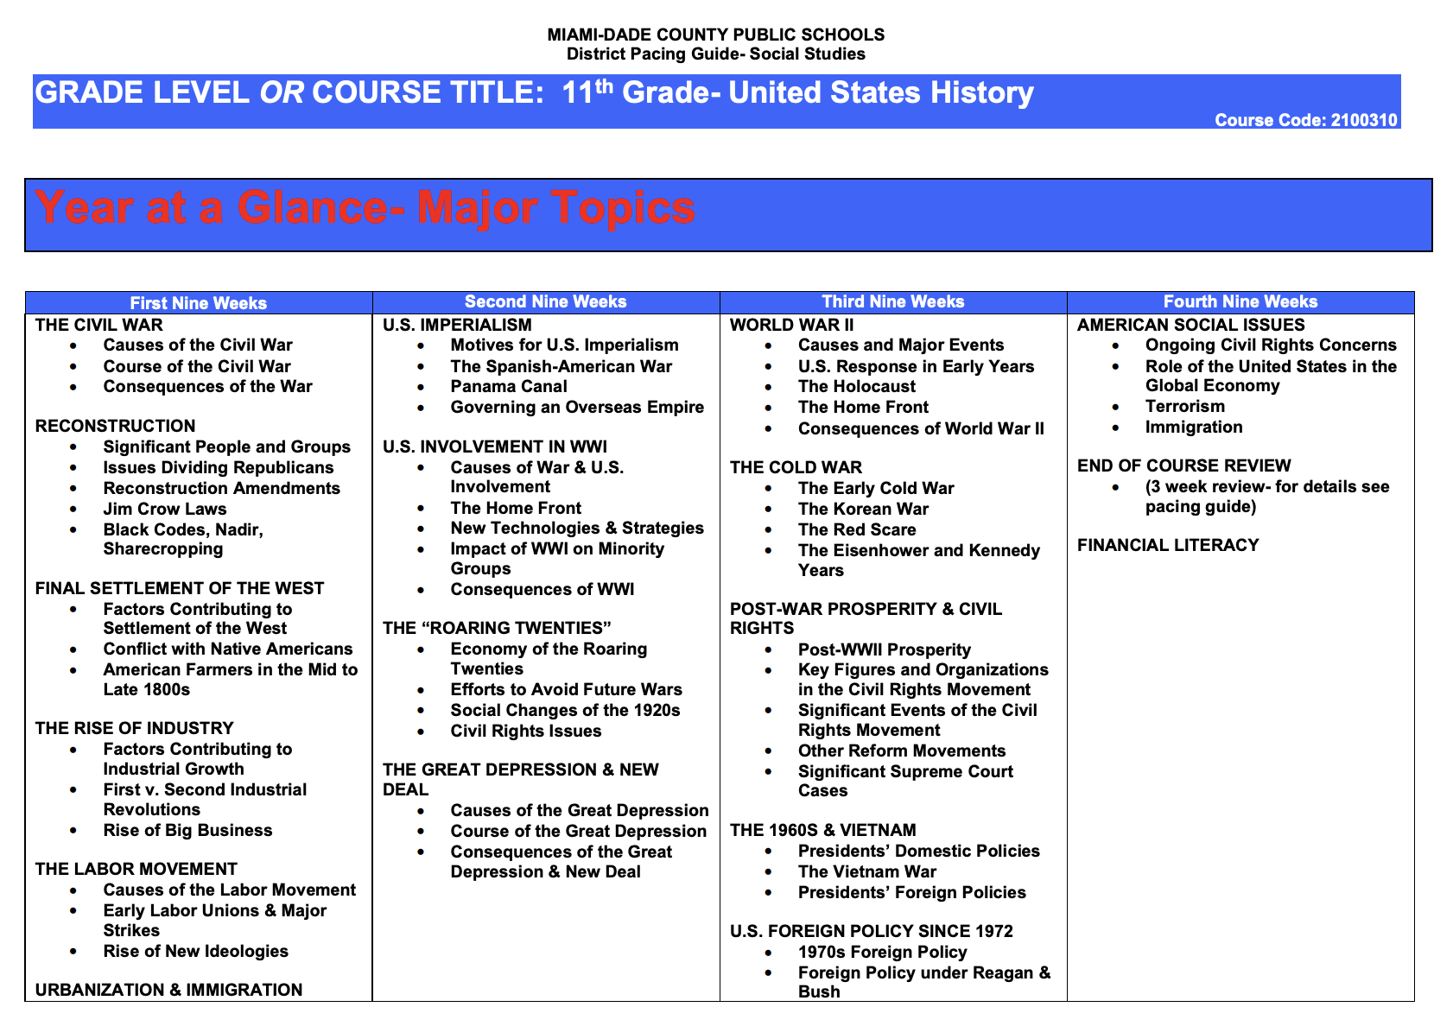**Curriculum “Year at a Glance”:**

## **Florida U.S History End of Course Exam (EOC) Expectations:**

#### **About the Test:**

* 65 Multiple Choice Questions
* The U.S. History EOC Exam is a computer-based test.
* All students enrolled in regular/honors U.S. History must take the EOC Exam. Student performance results are used to calculate 30% of a student’s course grade. U.S. History is a graduation requirement.
* The U.S. History EOC Exam and course addresses major topics, trends, and analysis of historical importance beginning with the Civil War and ending with Modern Times.

#### **What Skills Will You Need to Master:**

* Analyze primary and secondary sources of information.
* Interpret historical trends that span across multiple time periods.
* Evaluate history from political, economic, and social perspectives.
* Understand, evaluate, and interpret graphic information (e.g., from charts).
* Understand and be able to explain the meaning of political cartoons.
* Draw conclusions from multiple pieces of complex information.
* Research and write about important historical time periods.

#### **What Parents/Guardians can do at home to assist the student.**

* Provide a quiet, organized place to study
* Talk to students about what they are learning in their history class.
* Encourage students to watch the news, read the newspaper, and ask “why or how” questions
* Discuss current events.
* Discuss political, economic and social perspectives.
* Repetition and understanding of material is the key to success.
* Open and constant communication with teacher.